1. **Open visual studio 2019 and click Create a new project**

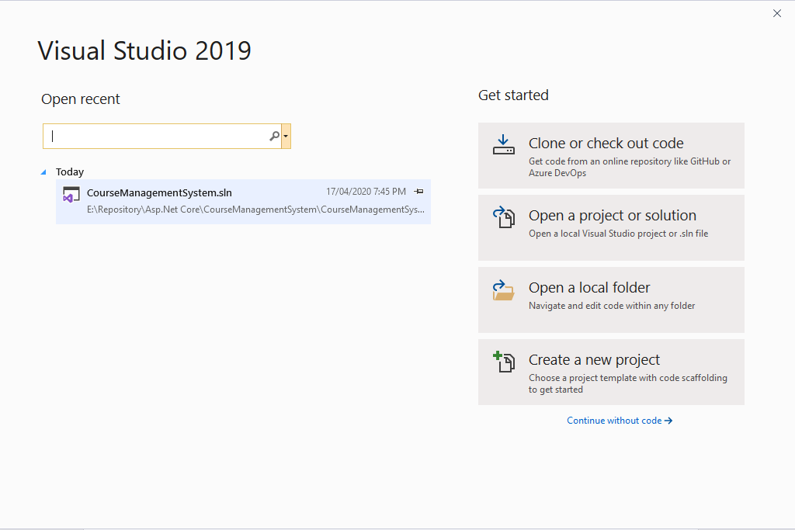

1. **Select Blank solution and click next**

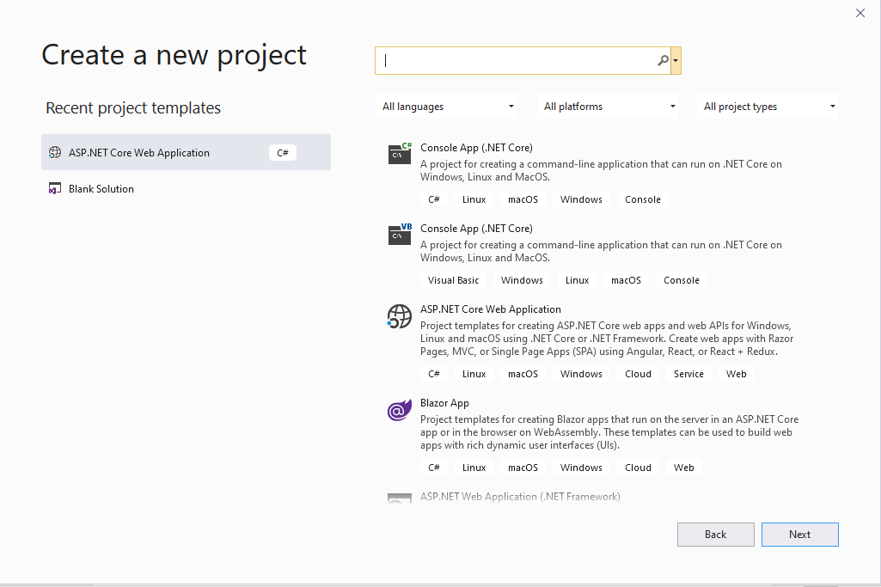

1. **Write the solution name “Course_Management_System” and click create.**

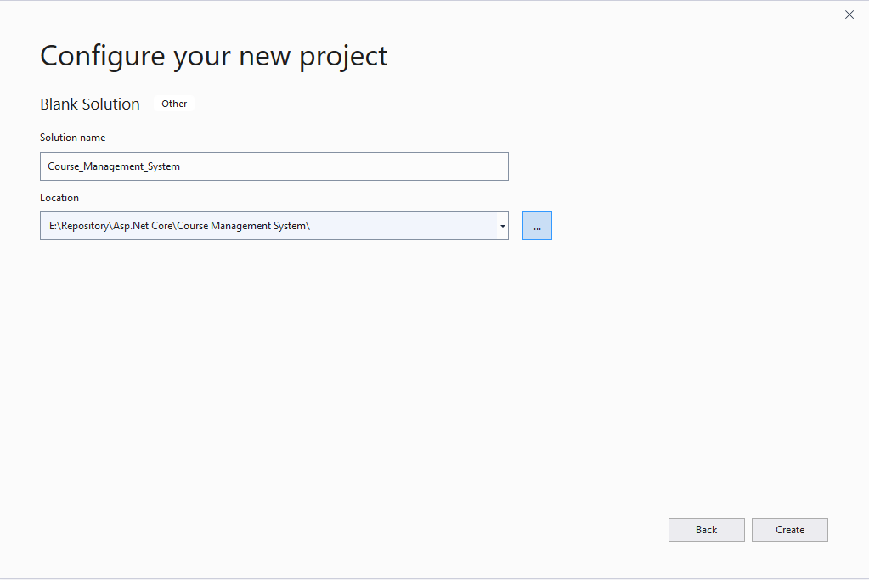

1. **Now solution will be like this.**

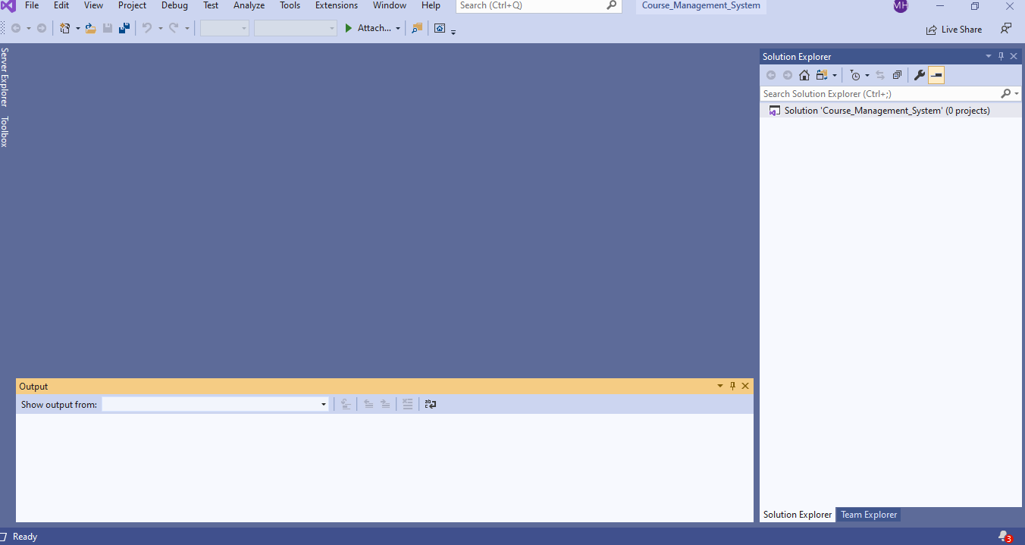

1. **Now right click on the solution and add new project**

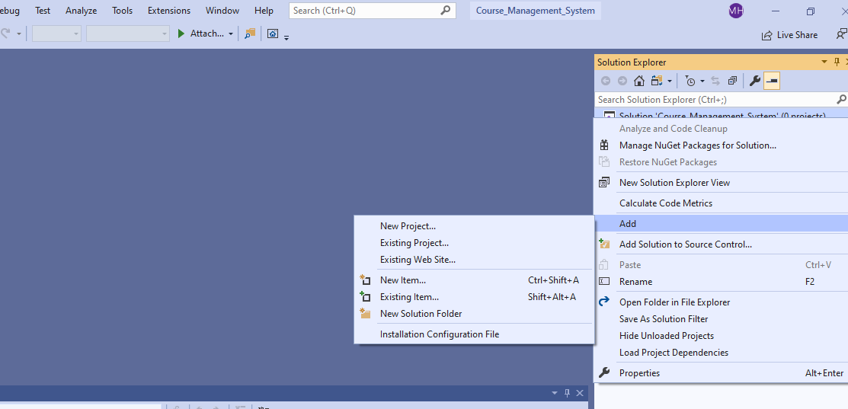

1. **Select ASP.Net core web application and click next.**

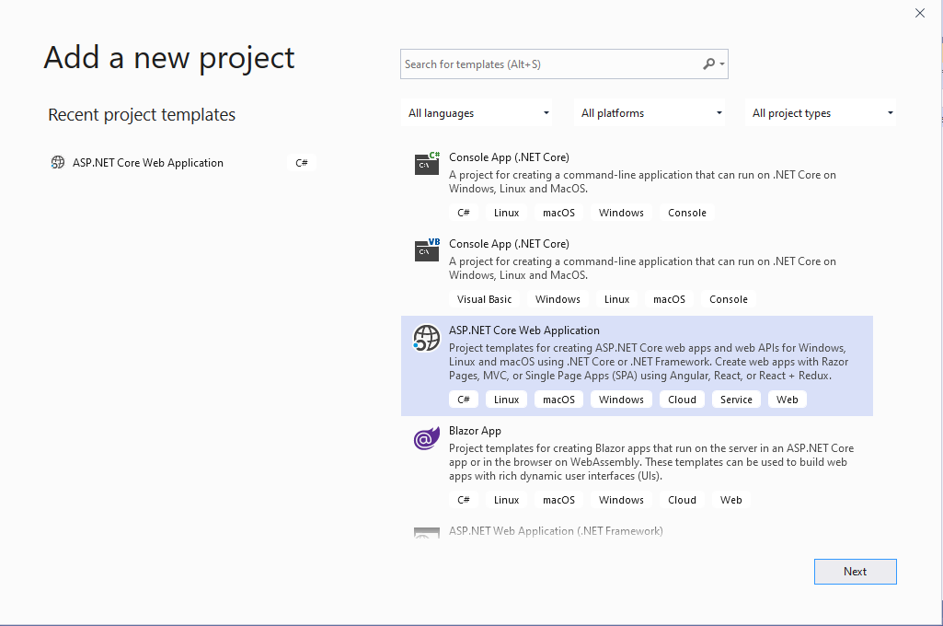

1. **Give the project name and click create.**

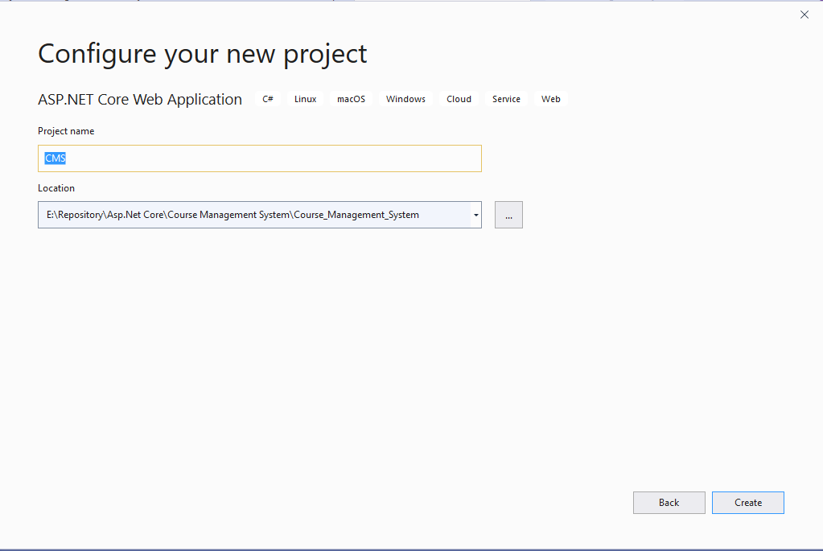

1. **After creating project select these things and click create**

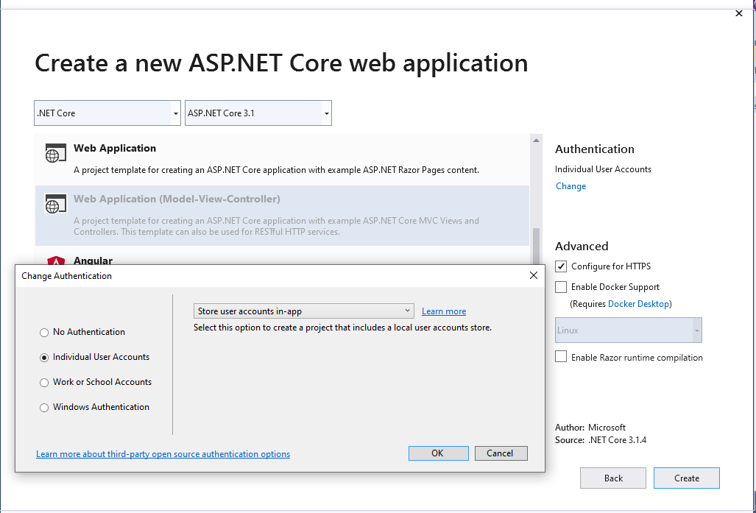

1. So, this the initial project

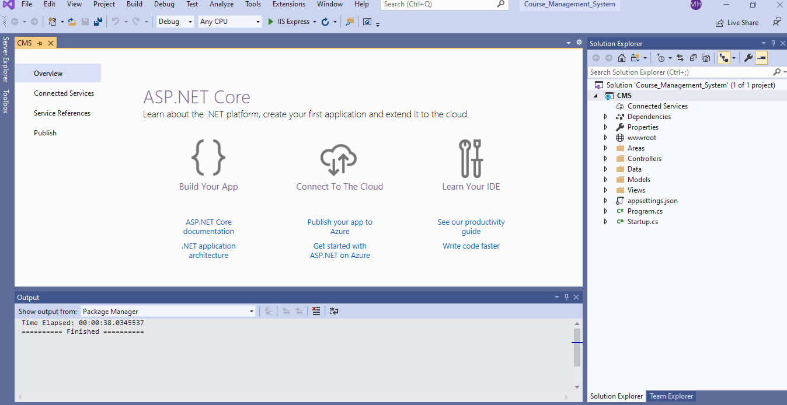

1. **Build the project and Click run**

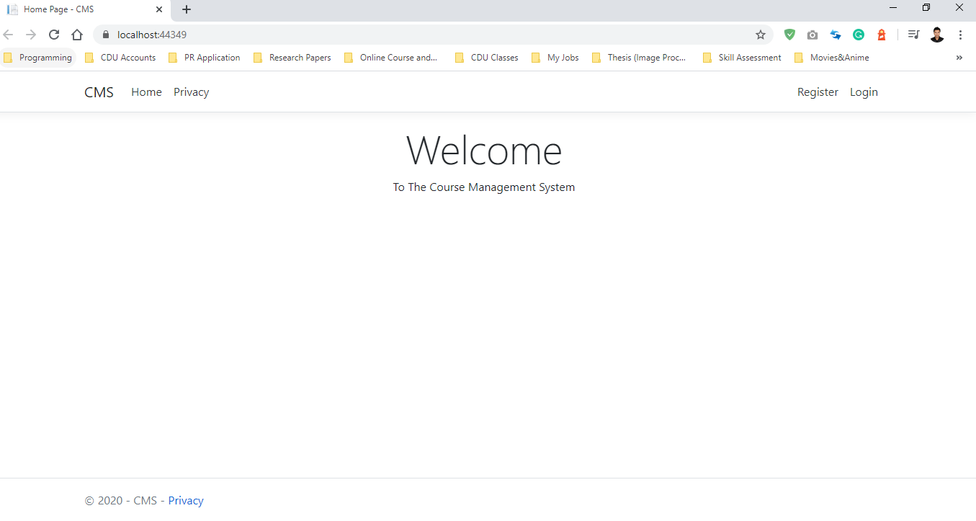

1. **Now change the connection string here**

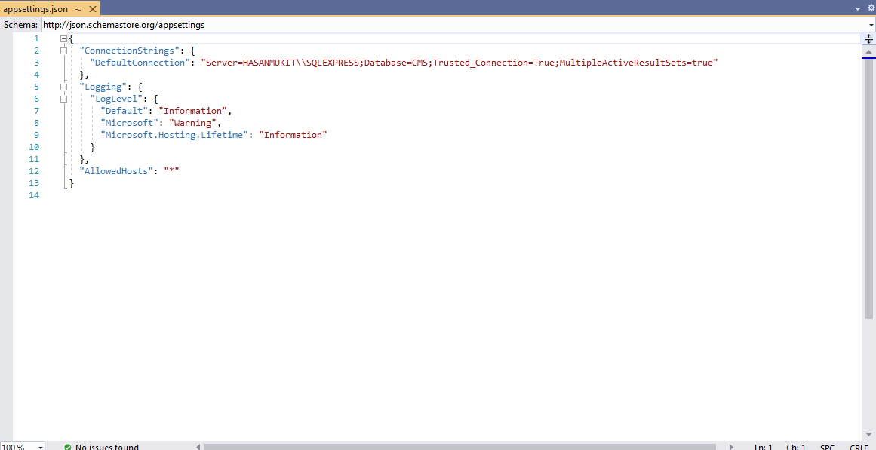

1. Now go to the visual studio and click **Package Manager Console**

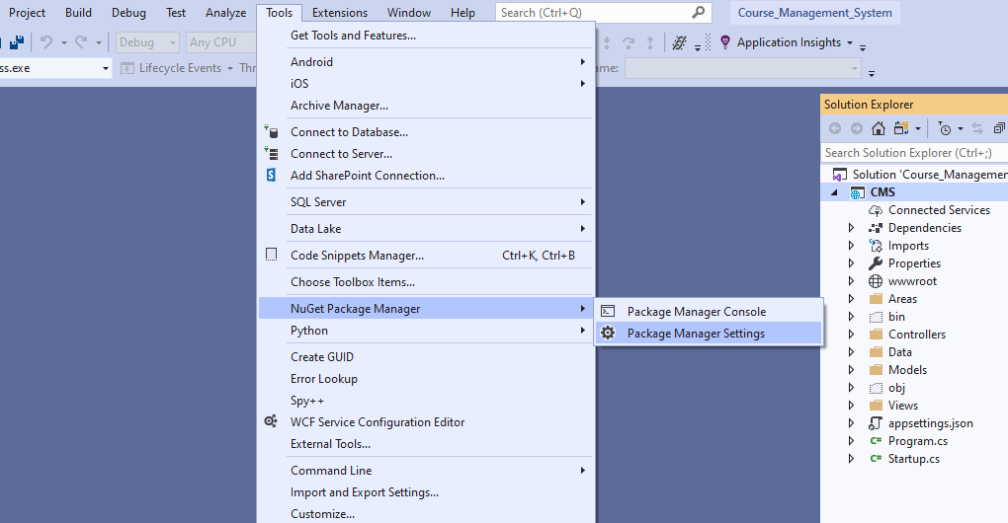

1. **Write “update-database”**

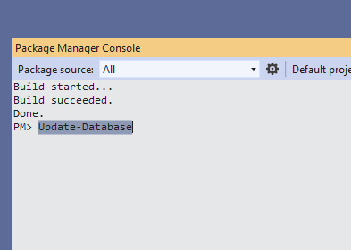

1. **Then database will be updated**

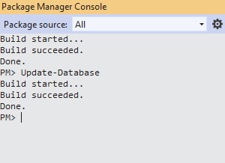

1. When you go to Sql Server Management studio, you will see the database CMS has been created.

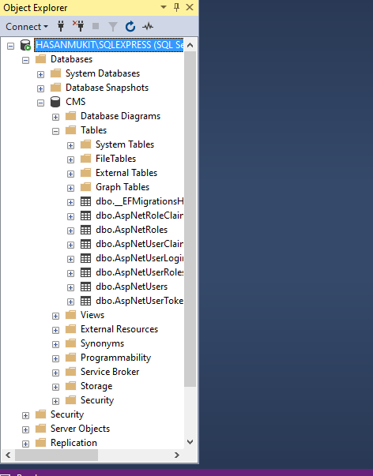

1. **Now click Register and register page will be open**

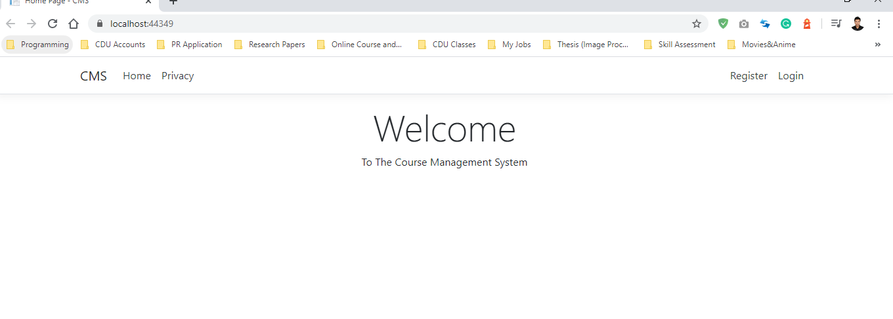

1. **Register page will be like this**

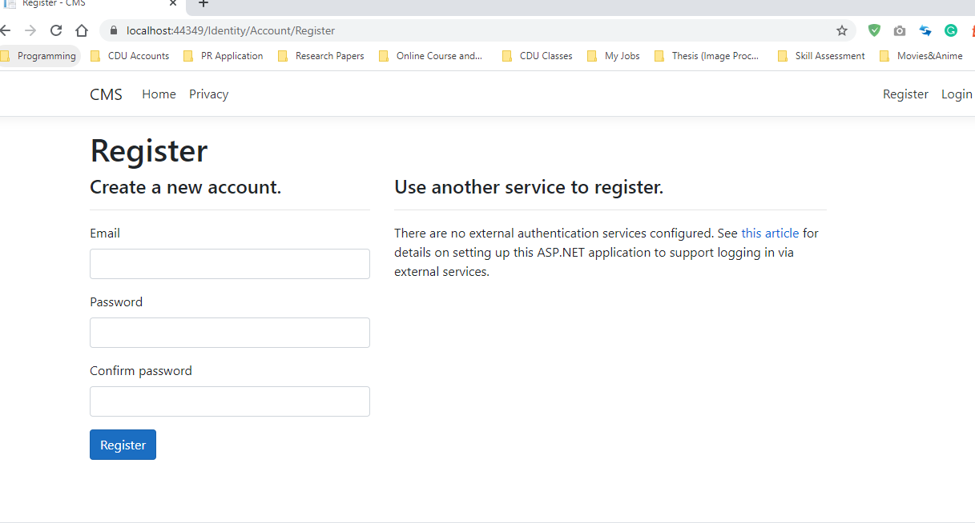

1. **Give all the information and click register and resister has been created. Now you can login**

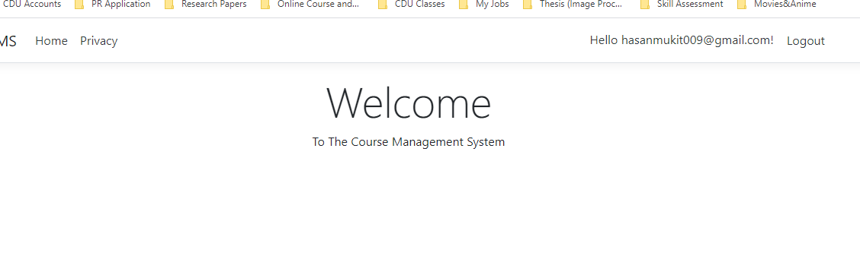

1. **Click log out and try login**

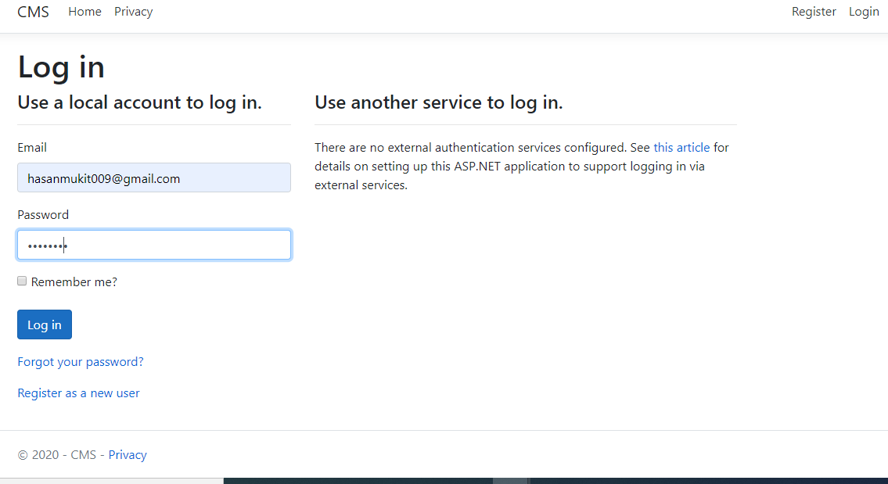

1. **This page will open**

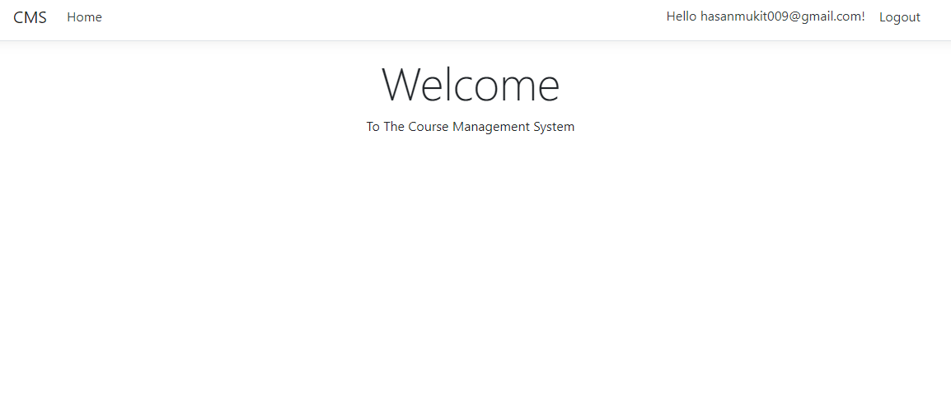

1. **Open layout page and add this code and run**

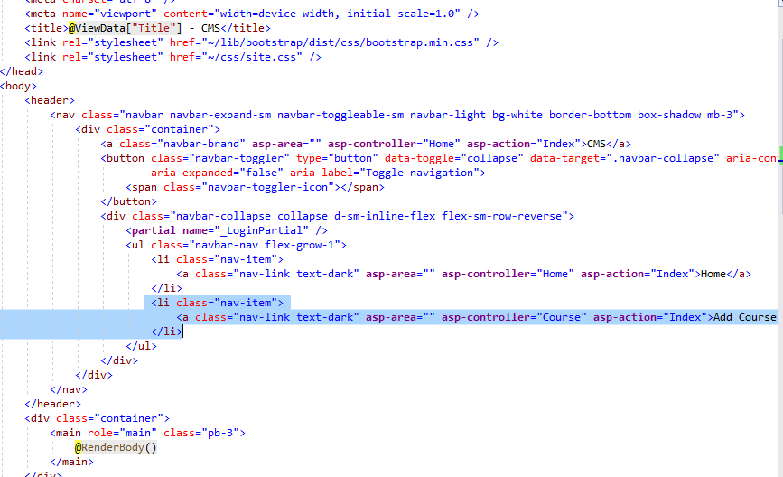

1. **Now click run and this will open**

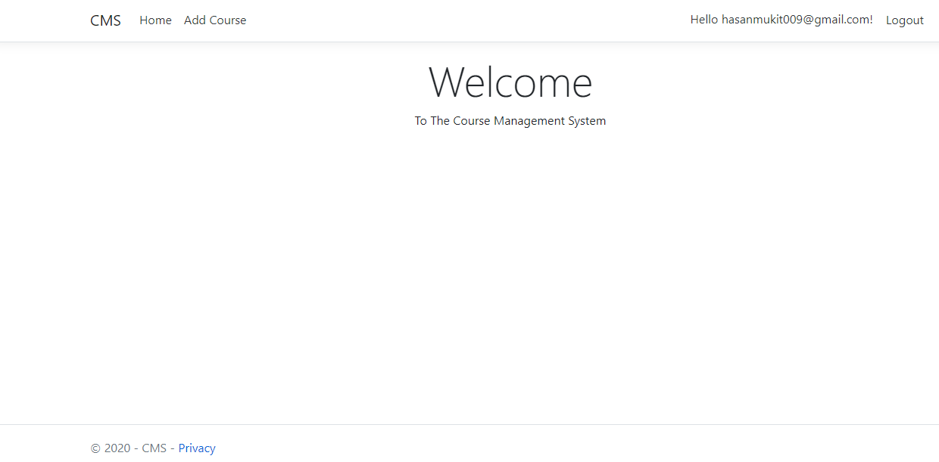

1. **Add Course class in model and click add**

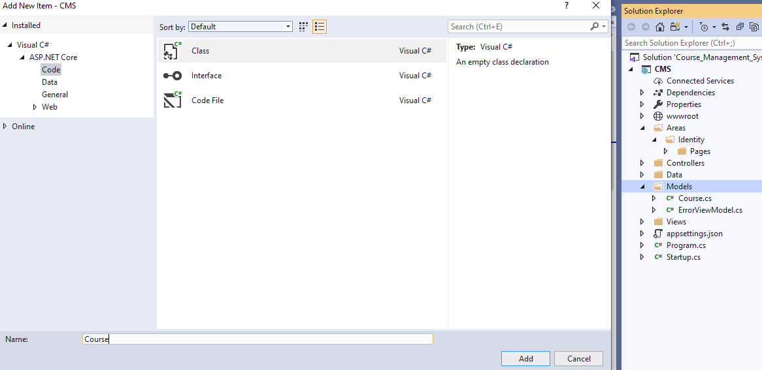

1. Add these codes in **Course.cs** Class

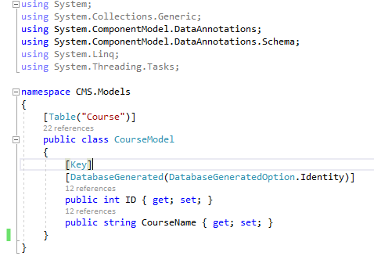

1. **Now open package manager console and write “Add-Migration AddCourse”**

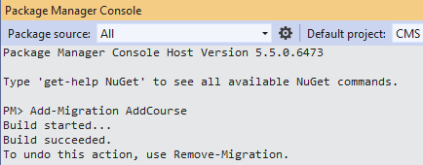

1. **Now write these codes in update-database**

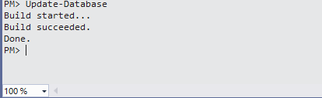

1. **Now open sql server management studio and you will the new table “Course” has been added.**

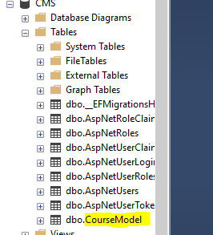

1. **Now add controller and select this and click add**

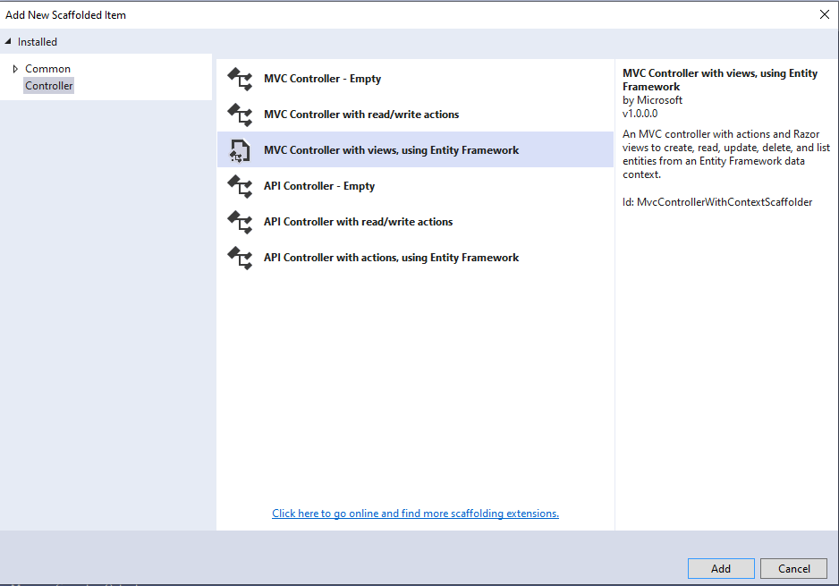

1. **Put all that information and click Add**

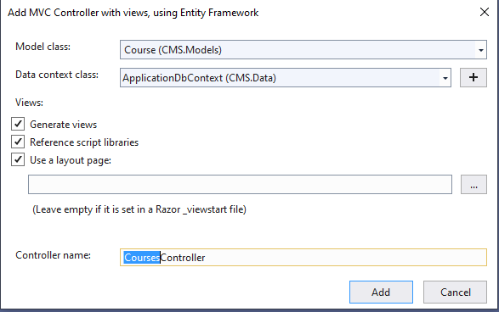

1. **Course controller will be added, and it will be like this**

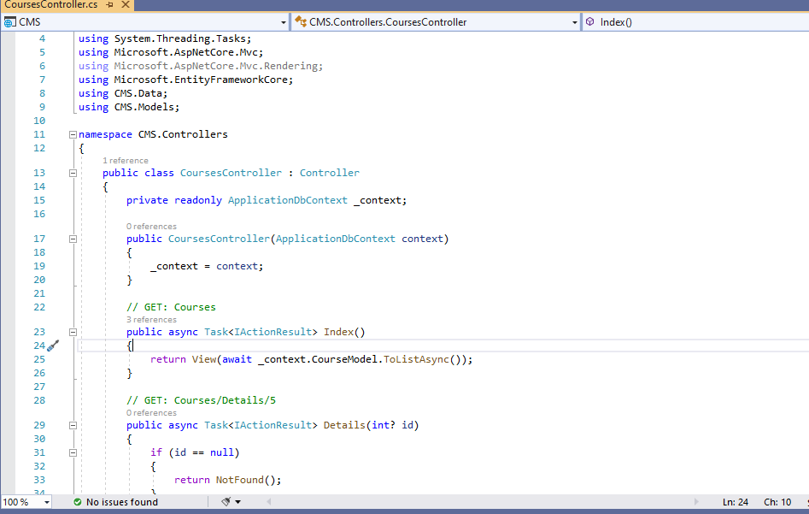

1. **Now run the project and you will see this**

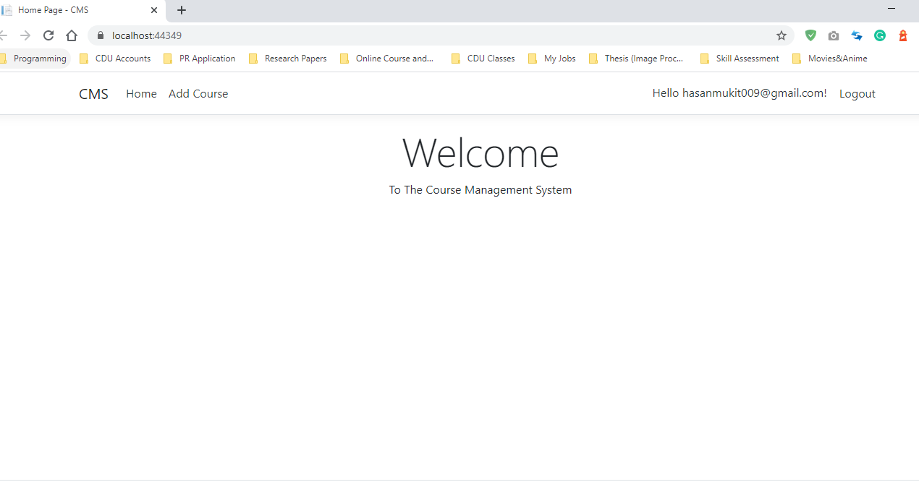

1. **When you click Add course it will be shown like this**

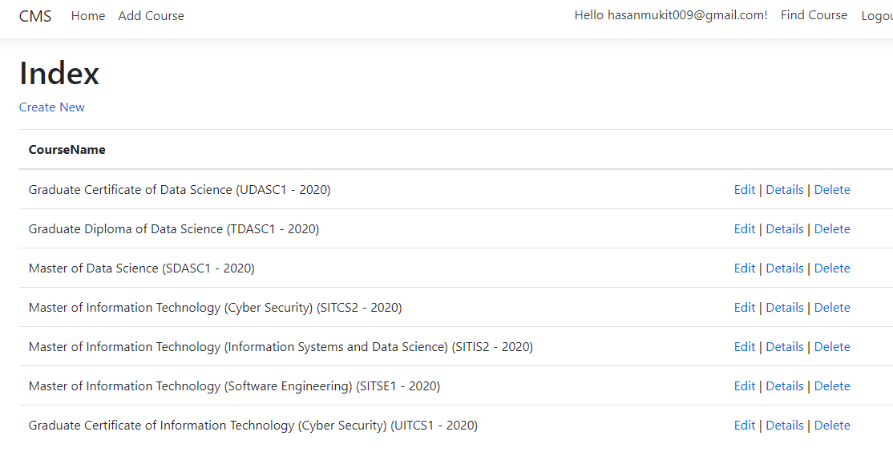

1. **Click create new and put this information and click create**

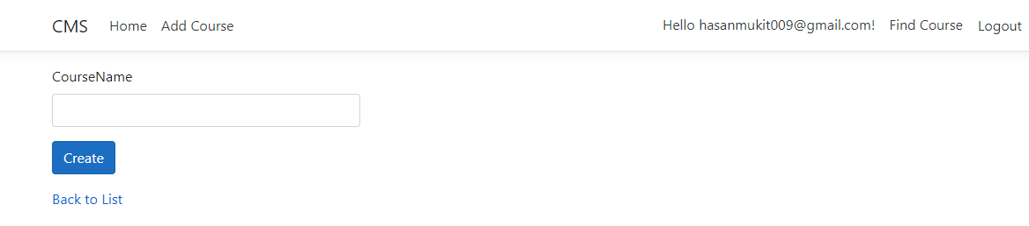

1. **It will be added to the list**

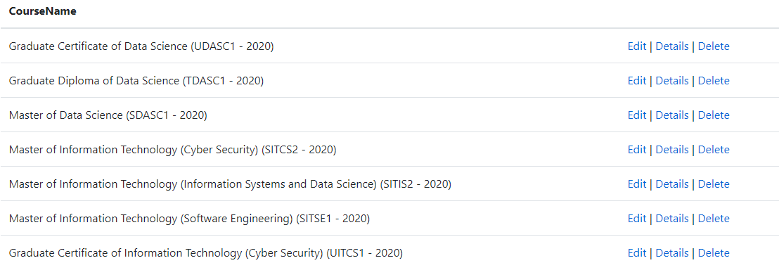

1. **You can edit and delete and show details from here**
2. **Now add this piece of code in _LoginPartial.cshtml**

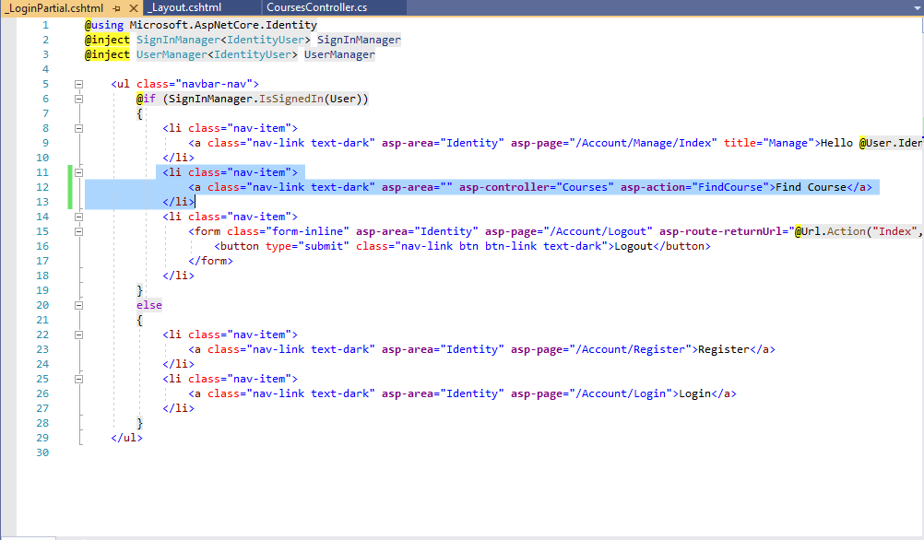

1. **Run the project and it will be like this**

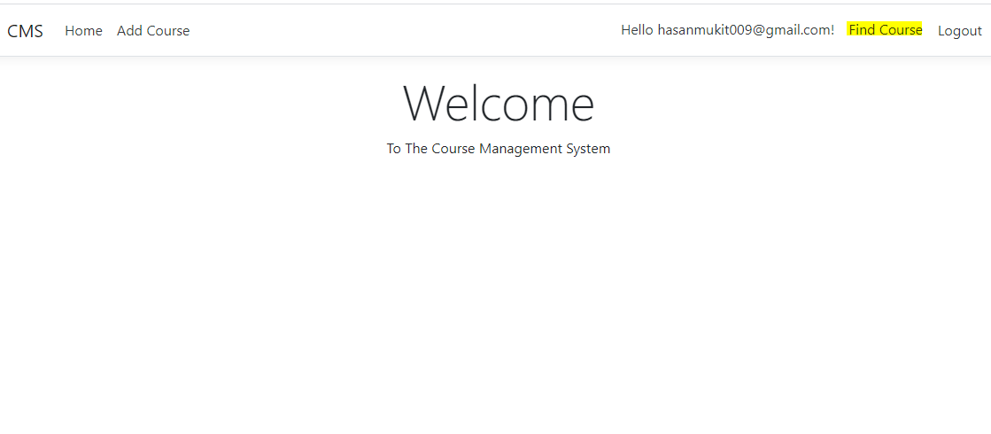

1. **Add this code in CoursesController**

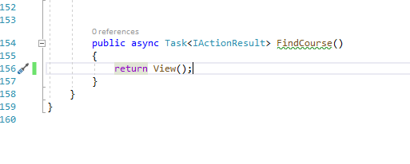

1. **Run and click Find Course**

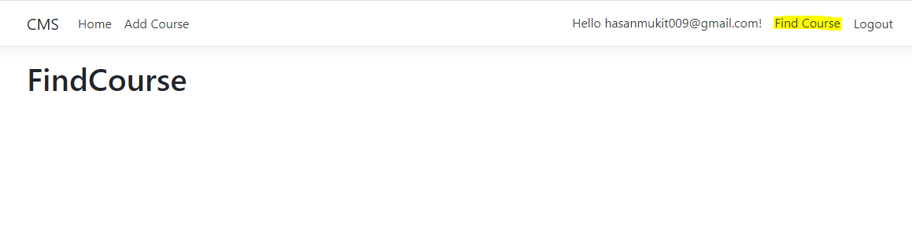

1. **Add this code to _Layout.cshtml**

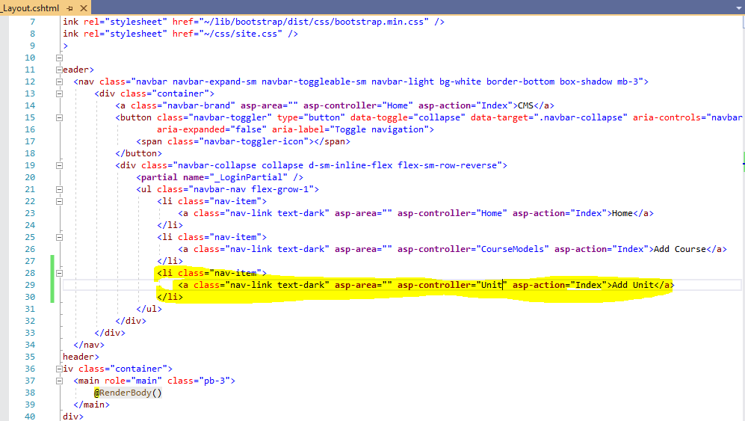

1. **Add UnitModel to model**

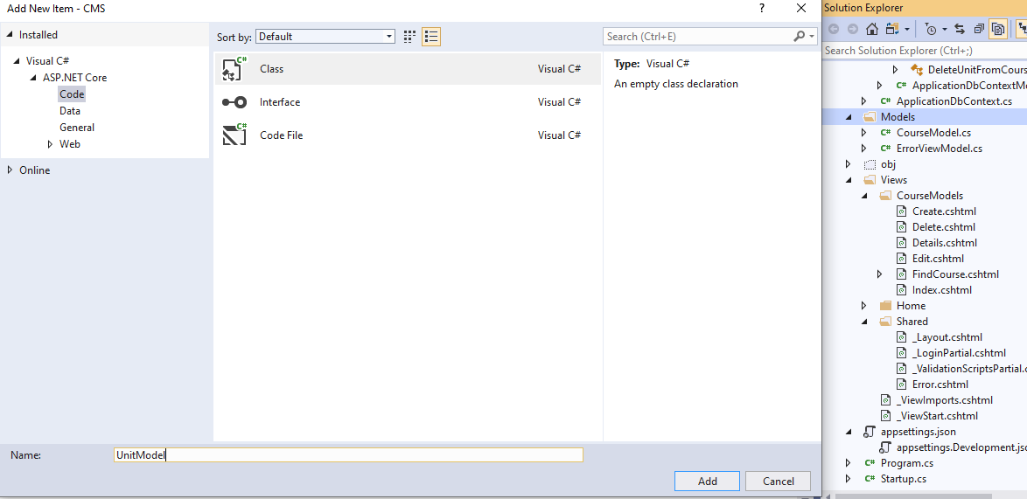

1. **Add these codes to UnitModel.cs**

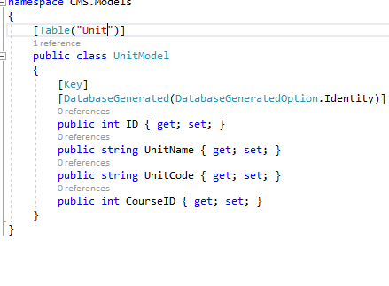

1. **Run these codes to package manager console**

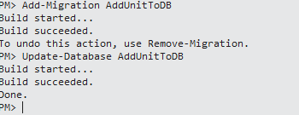

1. **Now you need to add controller to add unit**

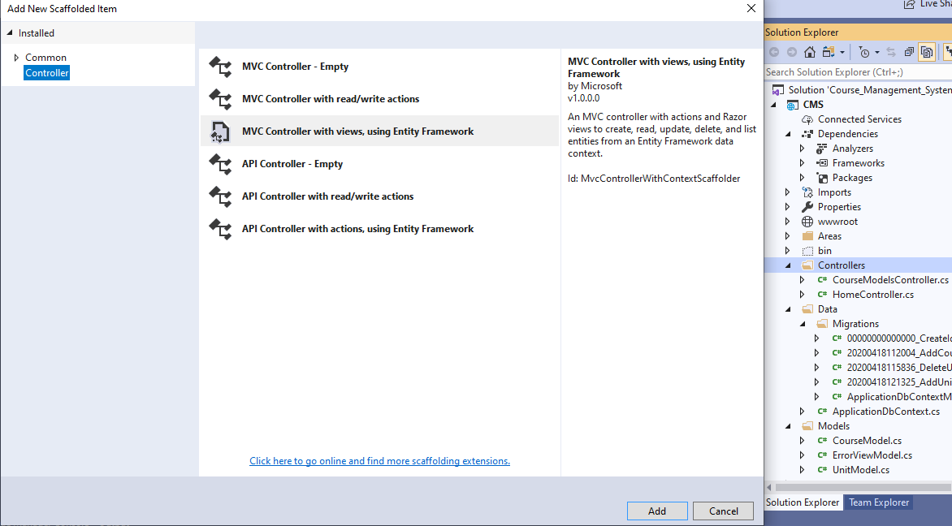

1. **After click add select these**

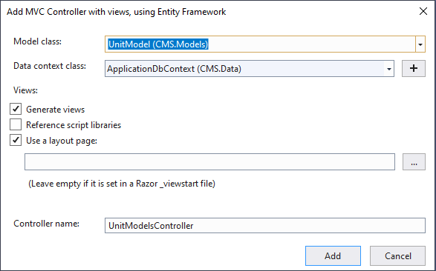

1. **Now Click add again**

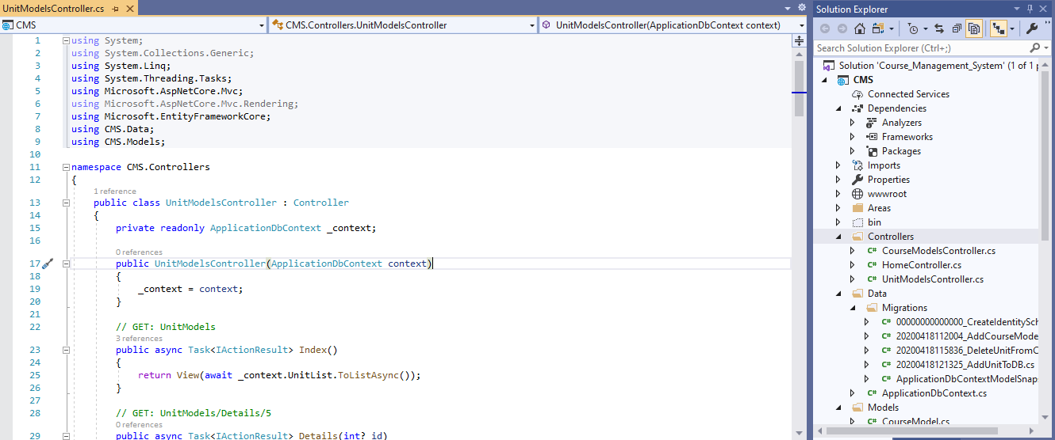

1. **Now run project and click add unit**

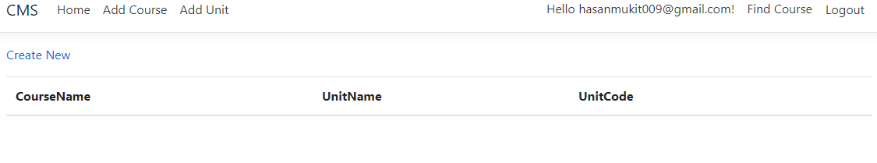

1. Click Create New and it will be like

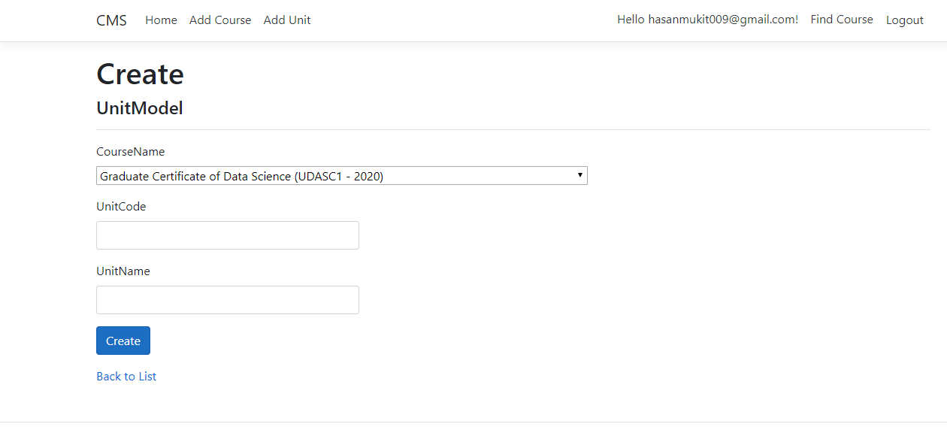

1. Now go to the UnitModelsController.cs and add these codes which will create Unit

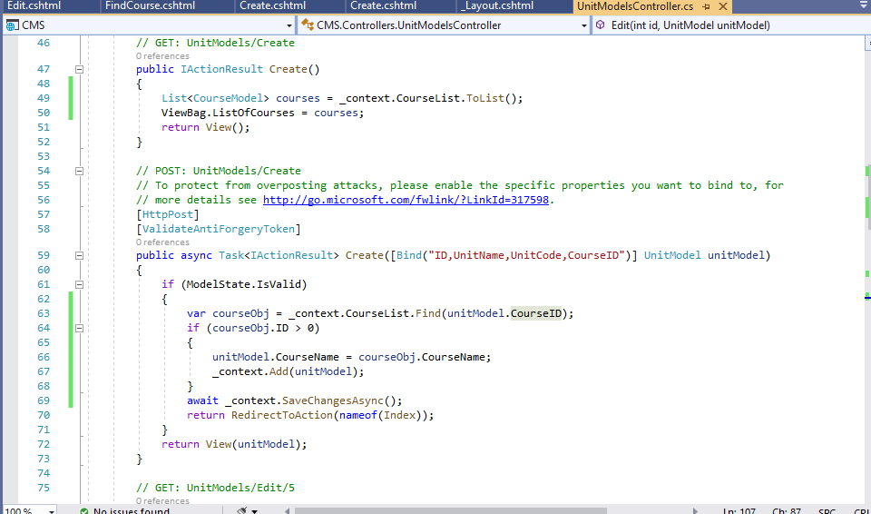

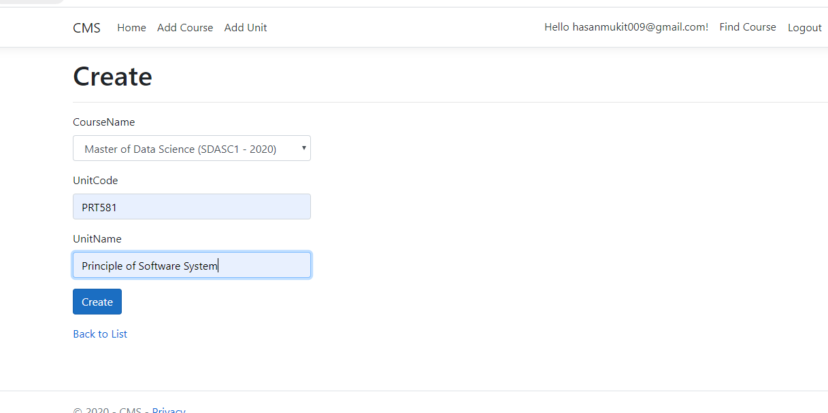

1. **Now Click create and information will be added.**

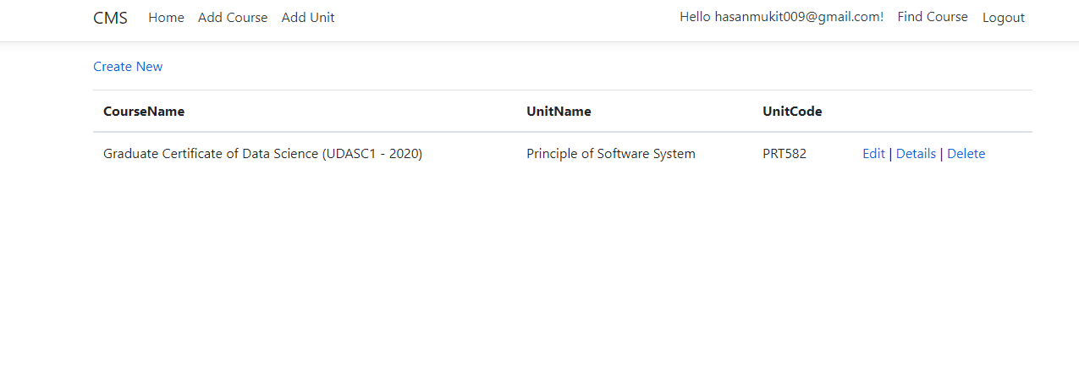

1. **It also can be edit, details and delete if you check the code in that UnitModelController.cs file**
2. **Now its time for the Find Course Functionality for students**
3. **So first create a model: StudentCourseModel.**

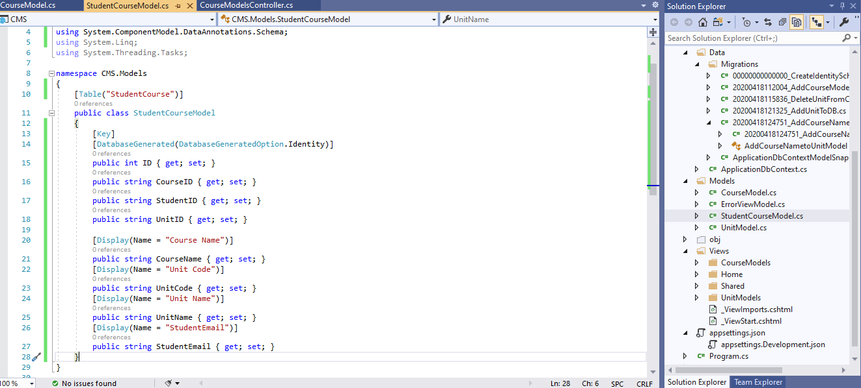

1. **Now add controller for studentCourse which is StudentCourseModelsController**

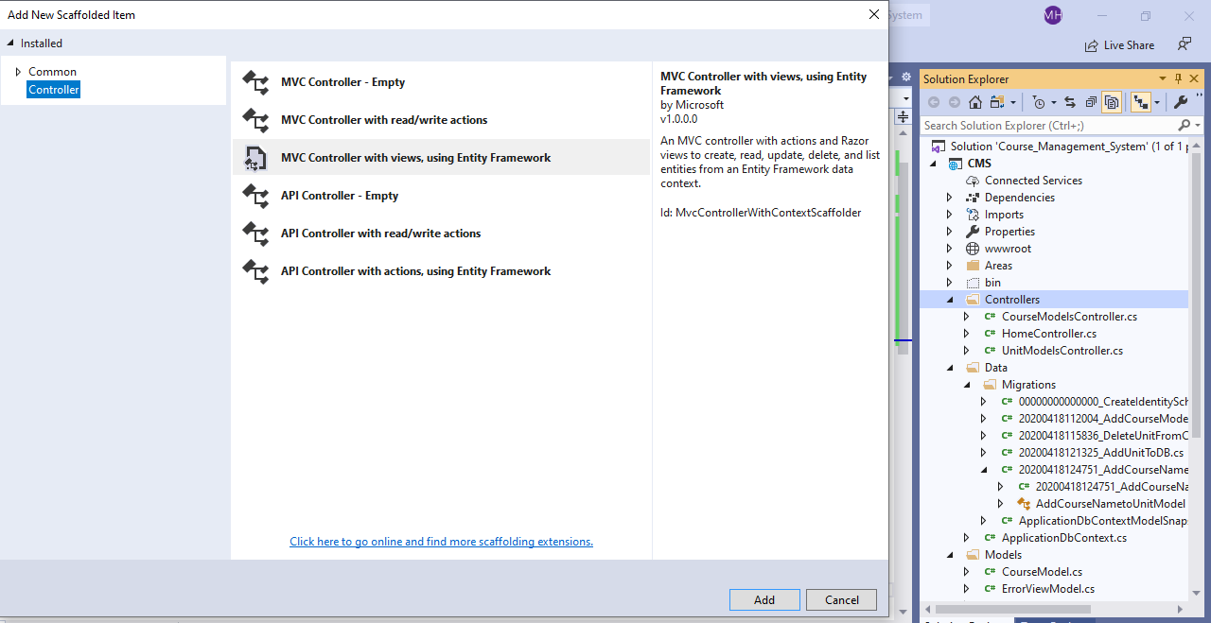

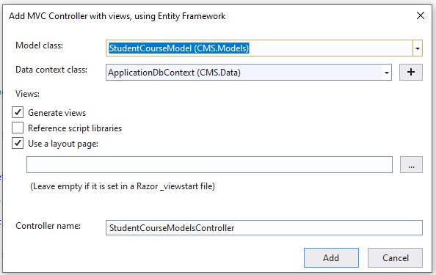

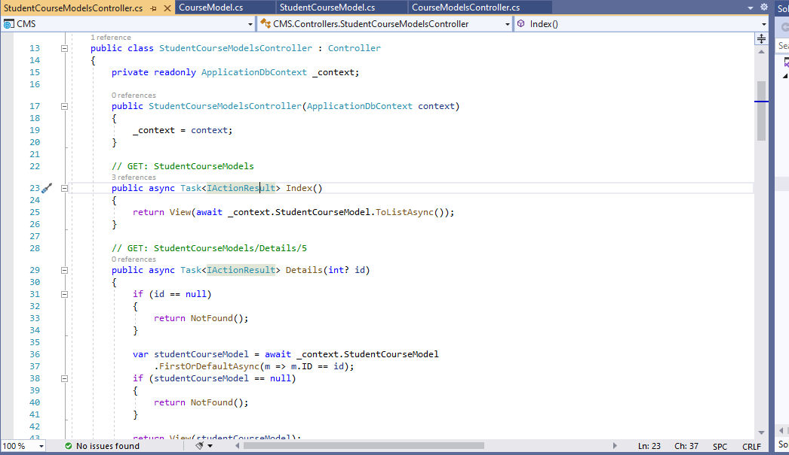

1. **Now Add code to give functionality for Add, Edit and Delete and Details. This is the page when you click Find Course**

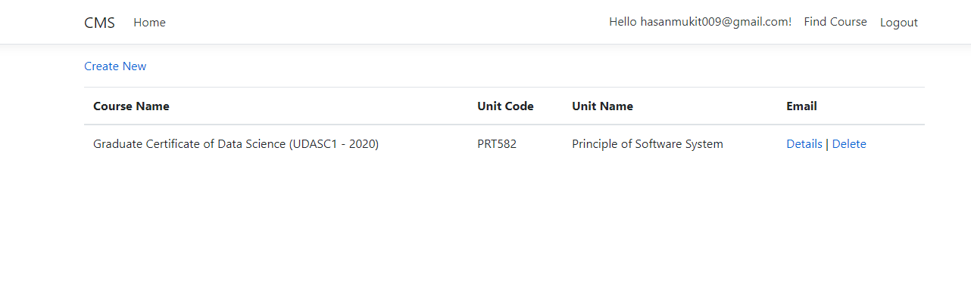

1. **Click Create New**

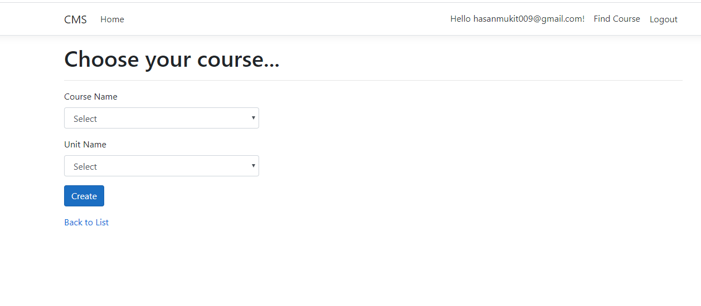

1. **This is the list of Course.**

